Profile the following table in the Northwind Traders Database. The first two have been done for you in the previous part.

|  |  |  |  |  |
| --- | --- | --- | --- | --- |
| **Table** | **Type** | **Row Count** | **Business Key** | **One Row Is** |
| Employees | Master Data | 9 | None (PK used) | An Employee |
| EmployeeTerritories | Business Process | 49 | None (PK’s used) | An Employee assigned to a territory. |
| Customers | Master Data | 91 | None (PK’s used) | A customer purchasing from Northwind Traders |
| Suppliers | Master Data | 29 | None (PK’s used) | A supplier selling us products |
| Products | Master Data | 77 | None (PK’s used) | Products sold by Northwind Traders |
| Shipments (of Orders) | Business Process | 809 | None (PK’s used) | Order with a not null Shipped Date |
| Details (of an Order) | Business Process | 2155 | None (PK’s used) | Description of an order |

Write SQL Queries to answer the following questions which might be associated with functional business requirements in a data warehouse. For each of the following provide a screen shot of the SQL query, its output, and make sure your name or netid appears in the screenshot.

1. List the customer contact names and titles sorted by company name.

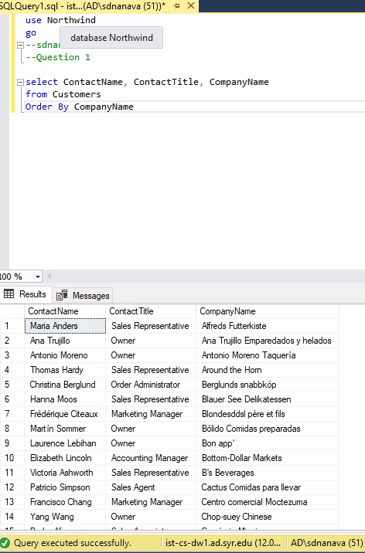

2. Factoring in discounts, what is total amount of product sold?

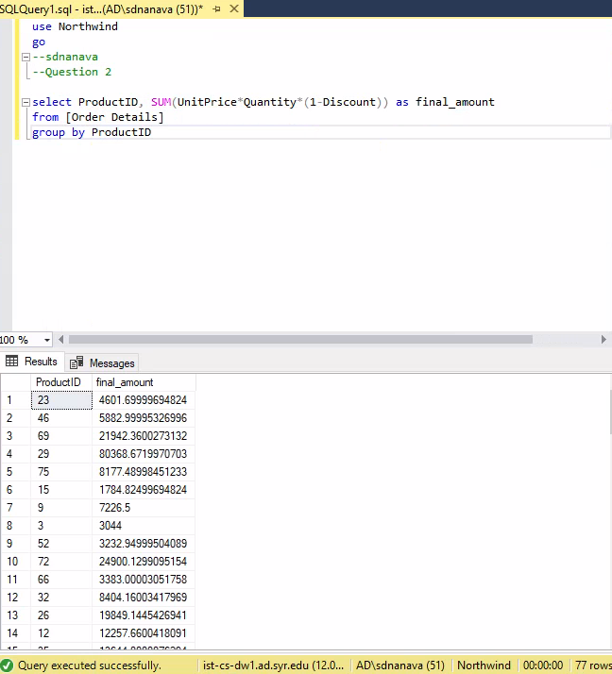

3. Provide a list of product category names with counts of products in each category.

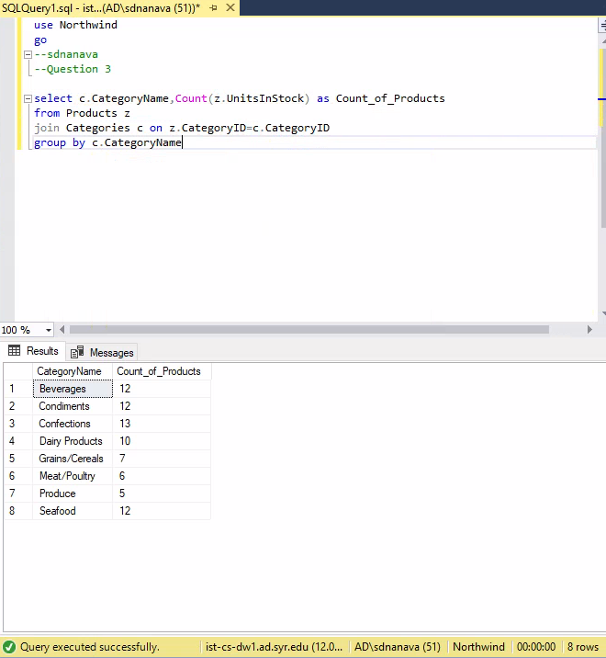

4. Select a specific customer, and display that customer’s orders with total amount of product sold for each order.

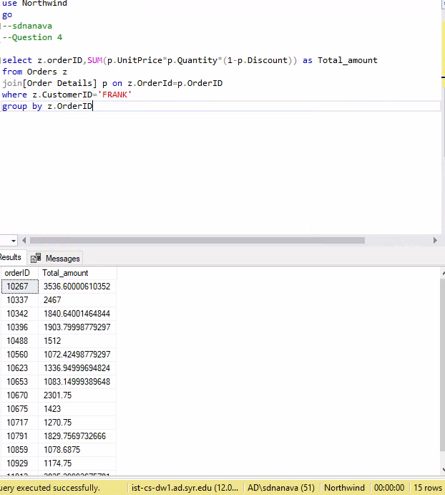

5. Select a specific employee and each order, how it was shipped (shipvia), the company who shipped it, and the total number of days elapsed from order date to shipped date

